**Singleton Pattern without Statics**

**Objective:** We’re going to introduce music to the game.

The problem is it means putting a music manager on the game scene and that means we would end up with multiple music managers when we load scenes.

**Singleton –** something that doesn’t like to be around other things of its type

Lets go to the splash screen and make sure our MusicPlayer is prefabbed. Go to Level one and add the MusicPlayer to the scene. Now if we go back to Splash and play what ends up happening is when we go to Level 1 we still have the original MusicPlayer, BUT if we die or the level releads it starts creating more and more music players. We need to prevent that.

1. Open **MusicPlayer.cs** and in the **Awake** method lets put a comment/pseudocode

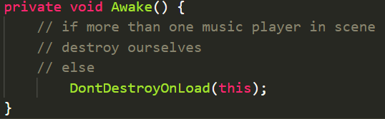

1. We need to find how many MusicPlayers there are. We’re going to use **FindObjectsOfType**

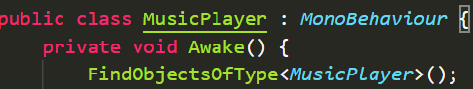

1. This is going to give us an array of music players. Lets find out how many are in this array so lets change the code to this

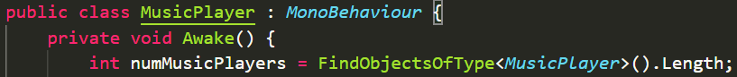

1. Now lets follow our pseudocode and turn it into code

|  |  |
| --- | --- |
| Pseudocode |  |
| Code |  |